**TECHNOLOGICAL INSTITUTE OF THE PHILIPPINES**

**QUEZON CITY**

**COLLEGE OF INFORMATION TECHNOLOGY EDUCATION (CITE)**

**ITE001- Computer Programming 1**

**NAME: Buenaventura, Aristotle C.**

**PROGRAM/SECTION: BSIT / IS11S1**

**ASSESSMENT TASK: Assignment 4.1 Returning Values from Function**

**1. Create a function that will determine the input number if odd or even. (no arguments and no return function.)**

1. **SOURCE CODE:** Write or paste the program code below.

#include <iostream>

using namespace std;

// Function with no argument and no Return value

void odd(); // function declaration

int main(){ // main function

cout << "\tTECHNOLOGICAL INSTITUTE OF THE PHILIPPINES QUEZON CITY" << endl;

cout << "\t\tFirst Semester S.Y. 2020-2021"<< endl;

cout << "\t\tITE001 Computer Programming 1\n"<< endl;

cout << "Name: " << "Aristotle" << "\t\tDate: " << "1/6/2021" << endl;

cout << "Program: " << "BSIT" << "\t\tSection: " << "IS11S1" << endl;

cout << "Assignment 4.1 Returning Values from Function\n"<< endl;

cout << "This program display if a given value is an ODD or EVEN number\n\n"; // purpose of this program

odd();

}

void odd() { // void function

int n;

do {

cout << "Please, Enter a value: ";

cin >> n; // user will input a value

if (n == 0) {

cout << "Invalid value, please refresh the program";

}else if ( n % 2 == 0) {

cout << n << " is even.\n";

}else

cout << n << " is odd.\n";

} while (n != 0);

} // end of program

1. **OUTPUT:**

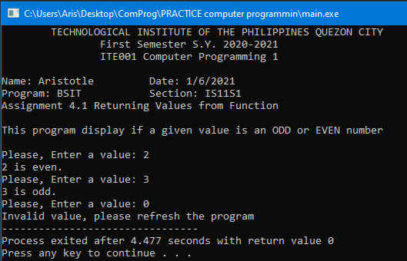

**2.** **Create a function that will convert the entered dollar into peso (with argument and return value).**

**1. SOURCE CODE:** Write or paste the program code below.

#include <iostream>

using namespace std;

// Function with with argument and return value

float convert(float); // function declaration

int main(){ // main function

cout << "\tTECHNOLOGICAL INSTITUTE OF THE PHILIPPINES QUEZON CITY" << endl;

cout << "\t\tFirst Semester S.Y. 2020-2021"<< endl;

cout << "\t\tITE001 Computer Programming 1\n"<< endl;

cout << "Name: " << "Aristotle" << "\t\tDate: " << "1/6/2021" << endl;

cout << "Program: " << "BSIT" << "\t\tSection: " << "IS11S1" << endl;

cout << "Assignment 4.1 Returning Values from Function\n"<< endl;

float dollar; //

float converted;

cout << "\nEnter the dollar amount that you want to convert in pero: ";

cin >> dollar;

converted = convert(dollar);

cout << "\nYour " << dollar << " dollar/s is/are converted to " << converted << " peso/s.\n";

}

float convert(float dollar){

float converted;

converted = dollar *48.09; // convertion of dollar to peso

return converted;

} // end of program

**2. OUTPUT:**

